**Quest 2**

Instructions: Open the "Foodmart_Data_Model.xlsx" worksheet that you saved on your desktop. This file was the finished product of your previous exercises. You should complete first all the first before continuing.

You should see all tables loaded under Data > Queries & Connections

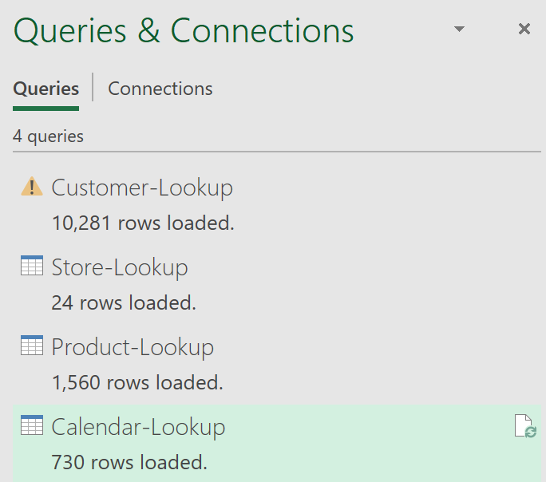



Now let's load our fourth file, the Calendar-Loopup.csv. Click Data, arrow-down of Get Data, From File, From Text/CSV

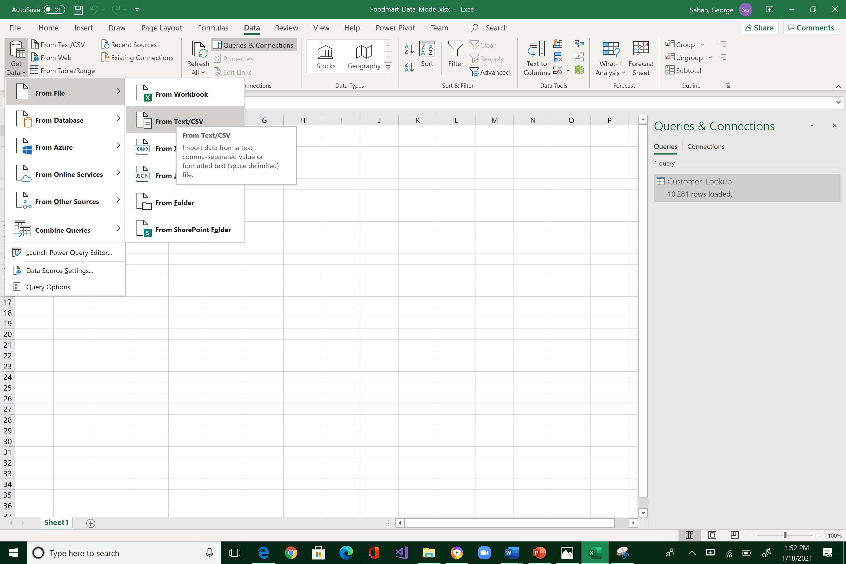



Navigate to where you store "FoodMart Data" (the files that you downloaded from Canvas last week) and select "FoodMart-Transactions-1997.csv".

You will see the import preview interface below. This is the window where we do data shaping, filtering, and transformation. From here, by default, you would always want to select Transform Data. So, click it!

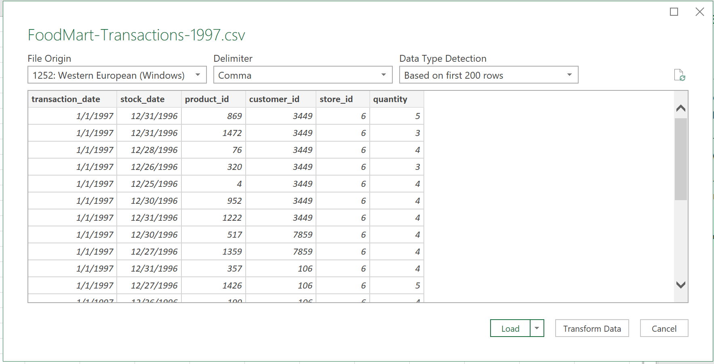



Now, let’s add an index column. Add Column > arrow-down of Index Column > From 1

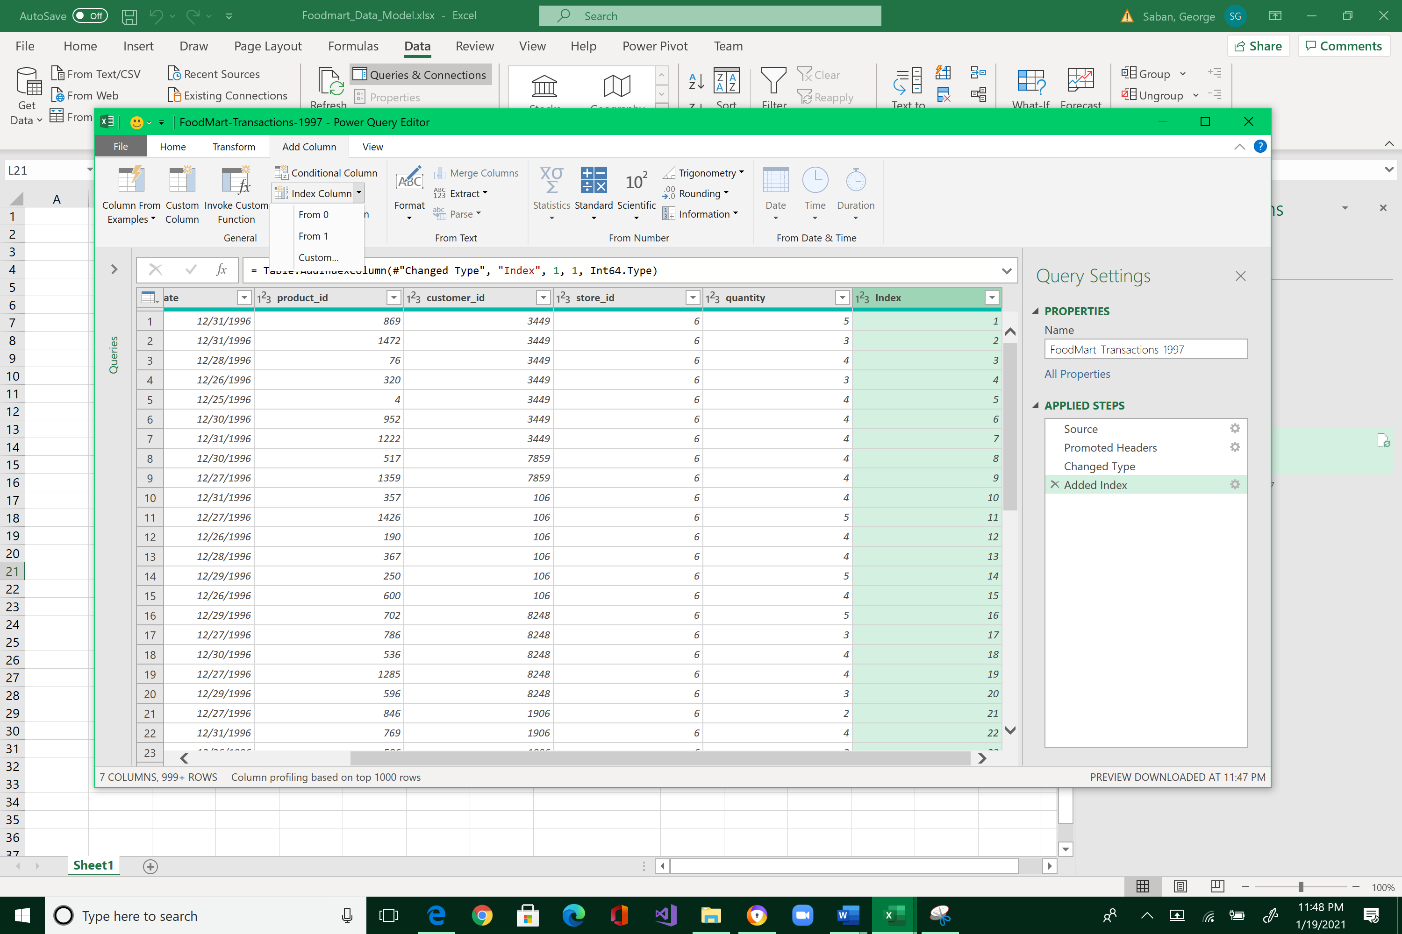



Change the type of the new column to Whole Number.

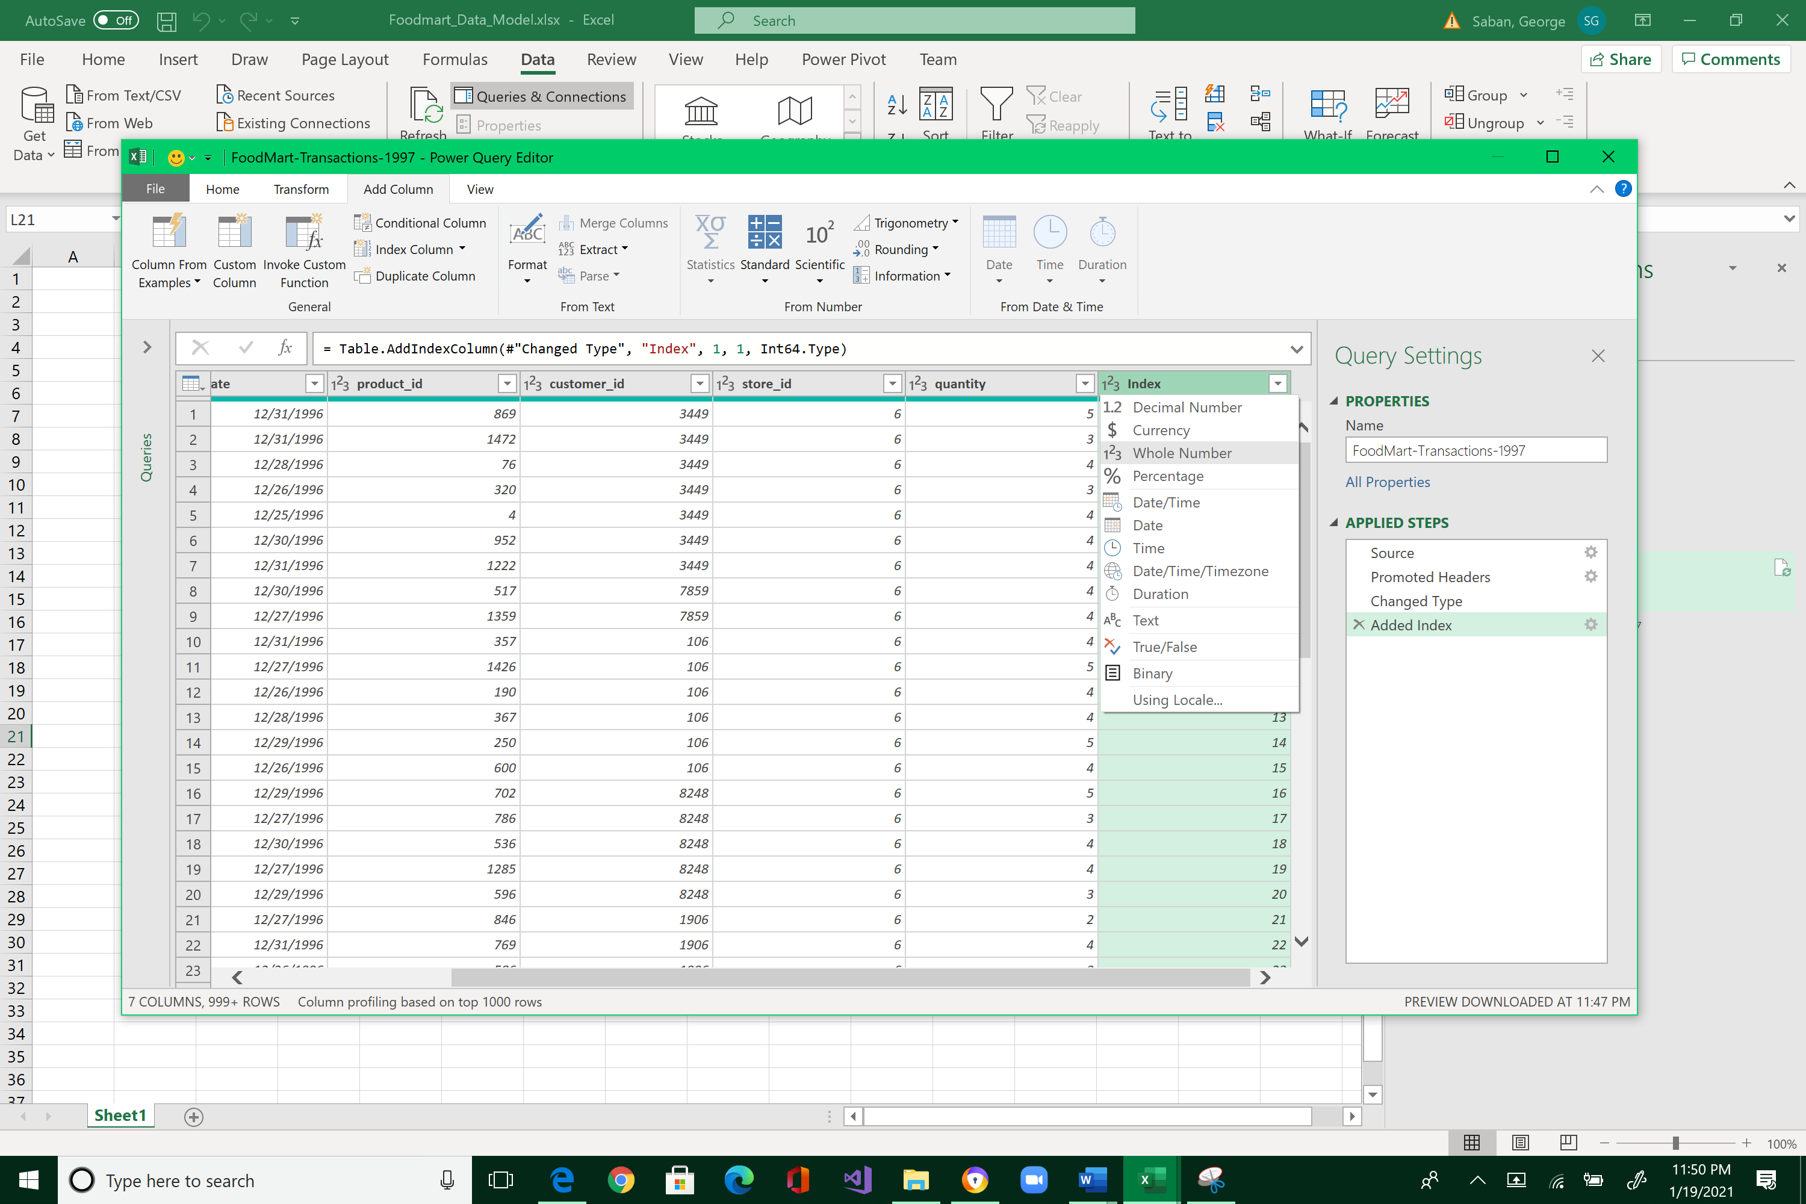



Rename the new column to transaction_id, and then drag it to the beginning of the table.

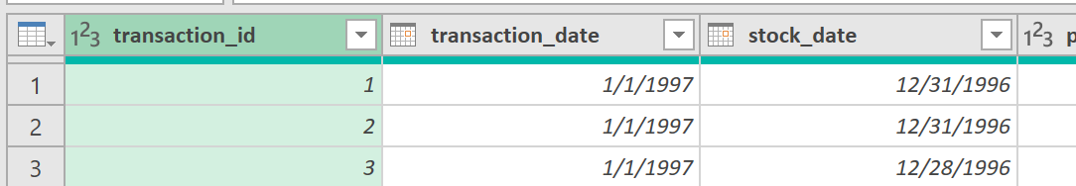

Rename the table to Transactions-1997

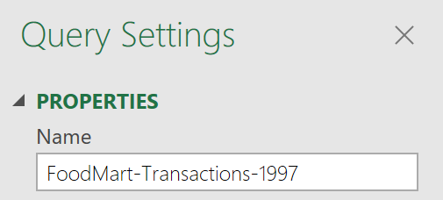

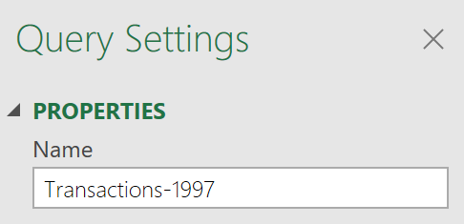



Note that this table is not a lookup table, but a transactional table.

Note also the columns product_id, customer_id, and store_id that maps this table to the associated lookup tables Product_Lookup, Customer_Lookup, and Store_Lookup.

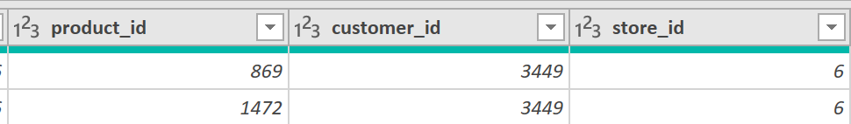

Now, let’s build a conditional column based on the quantity field. Highlight the quantity column > Add Column > Conditional Column

This will open up the Add Conditional Column dialog box.

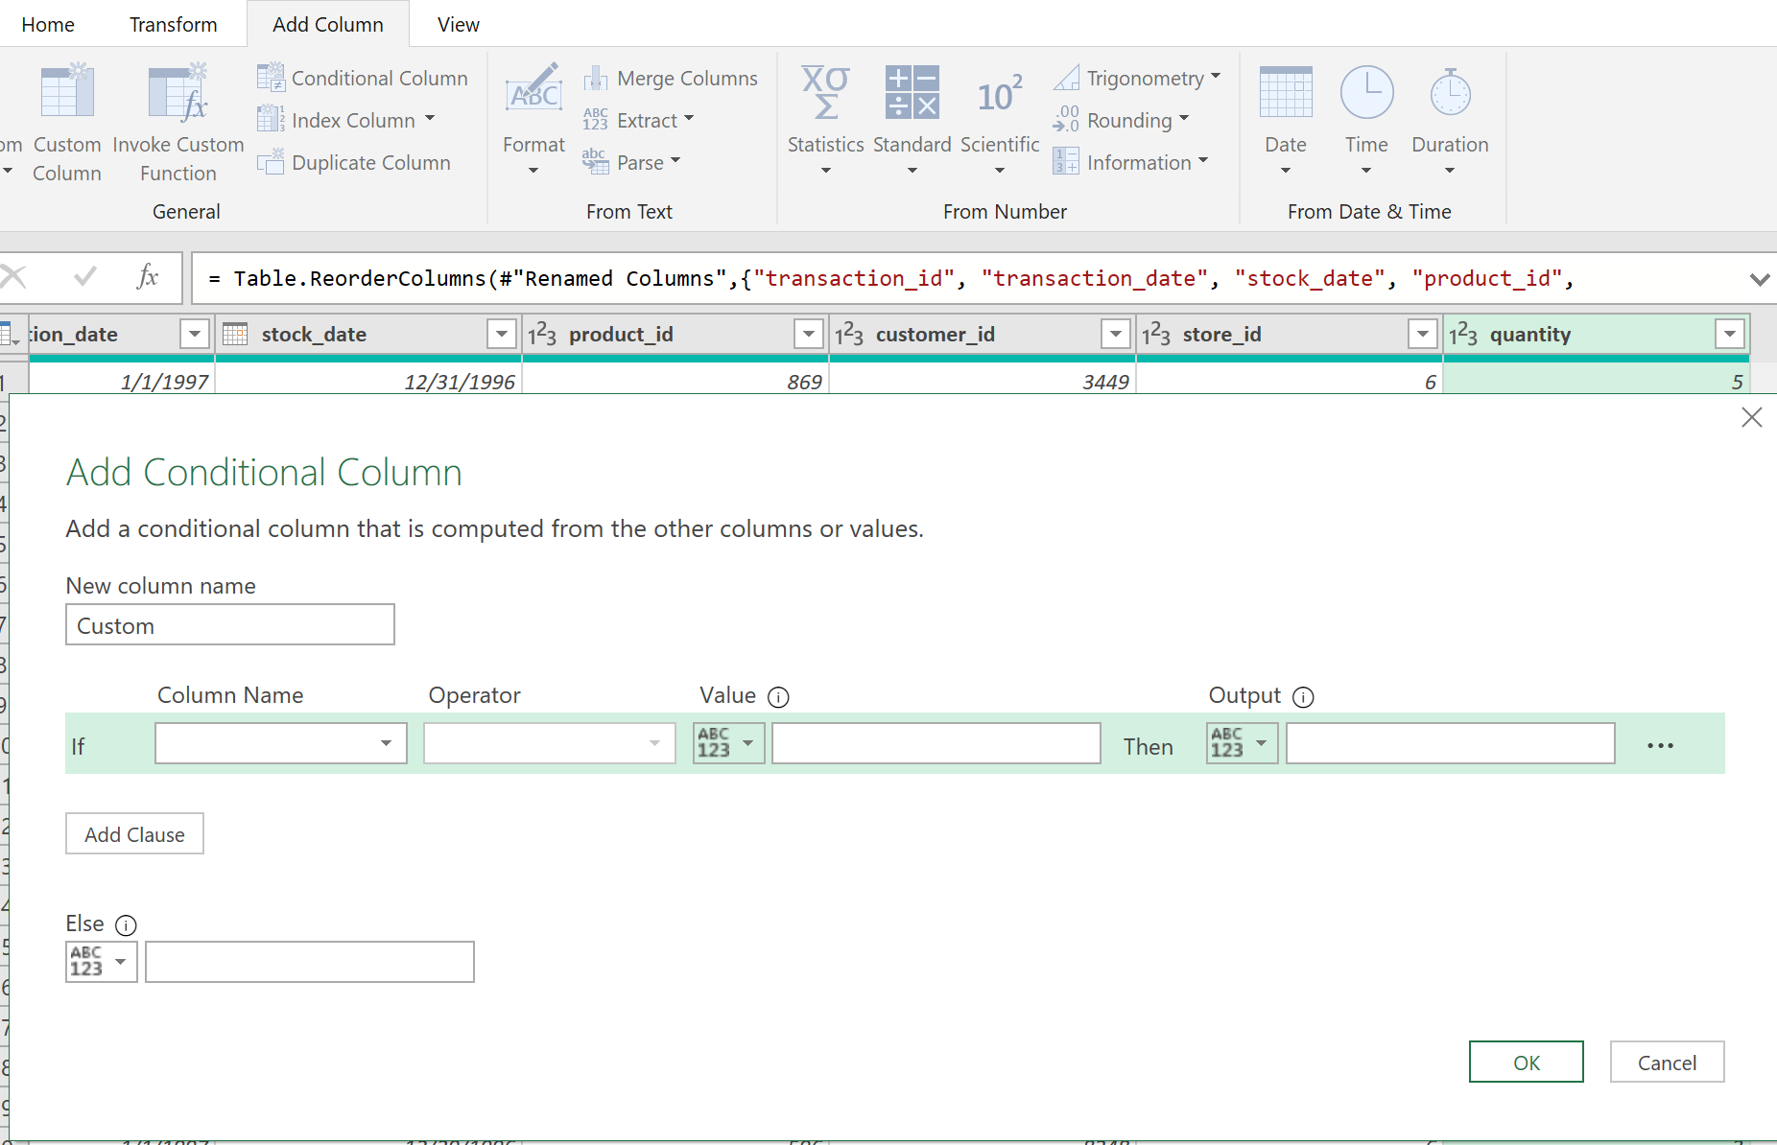



Give it a name: order_size

Add the rules

Click Add Clause to add additional rules, then click OK

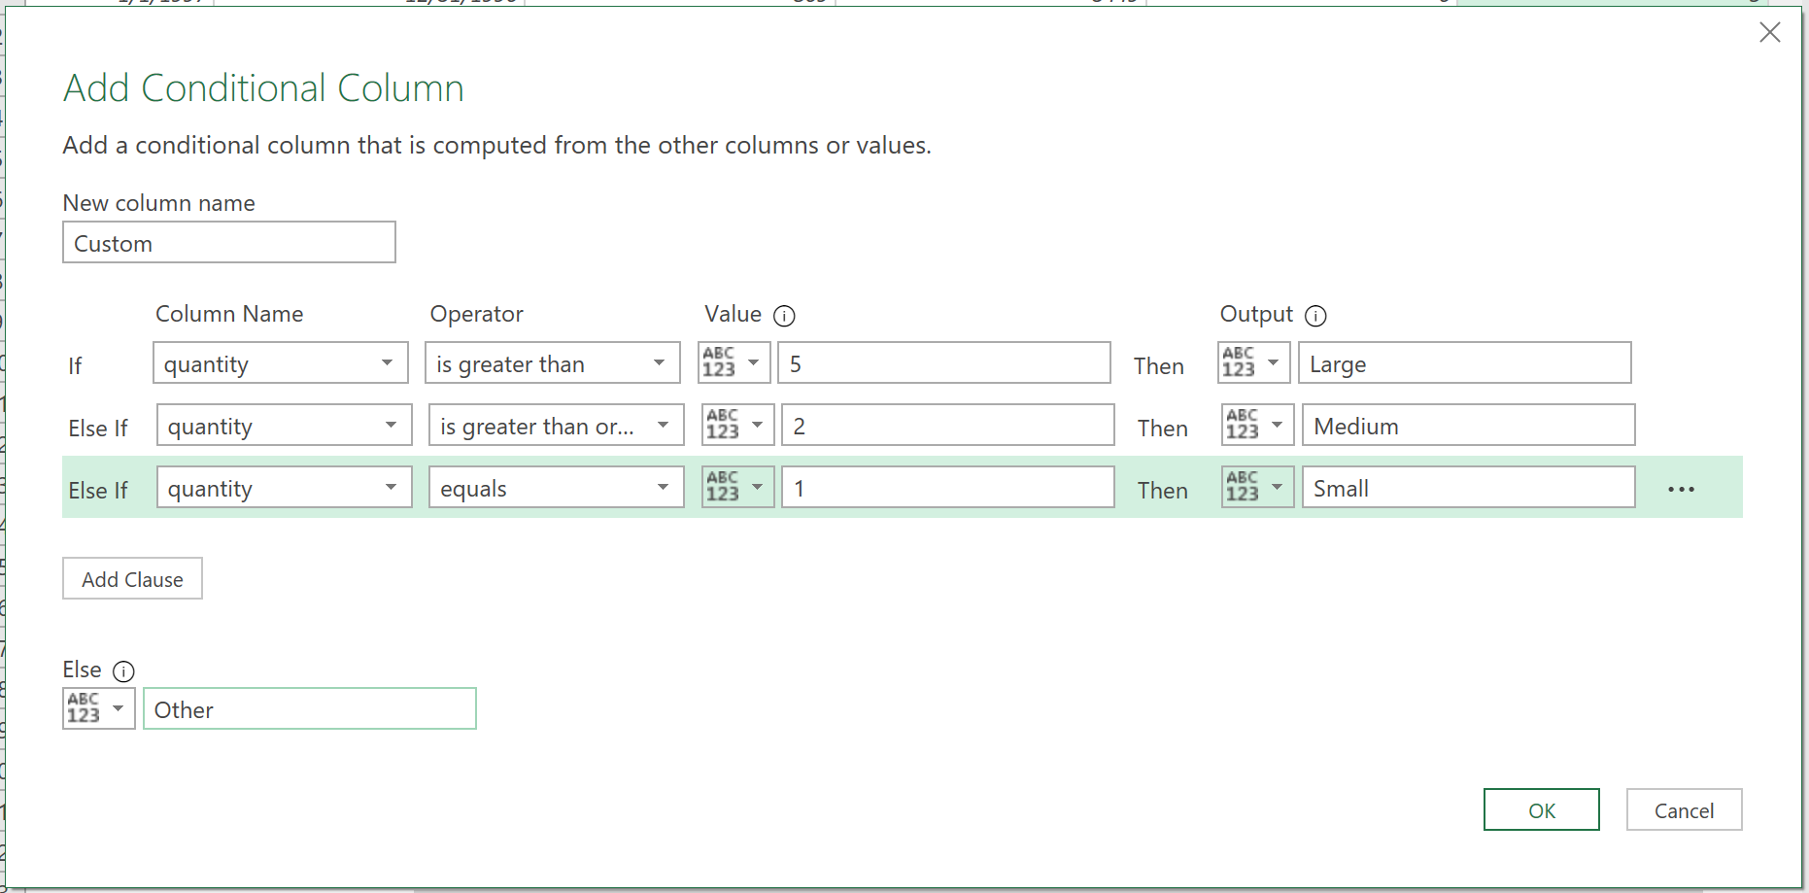



Note the addition of Custom column.

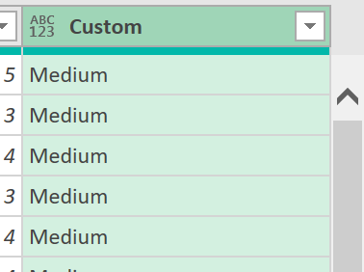

Rename it to order_size.

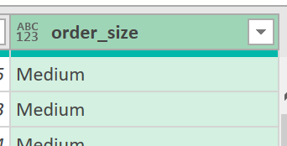

The last step is to Close & Load your work. We will always choose Close & Load To... Be careful not to click the diskette icon but select the small arrow down.

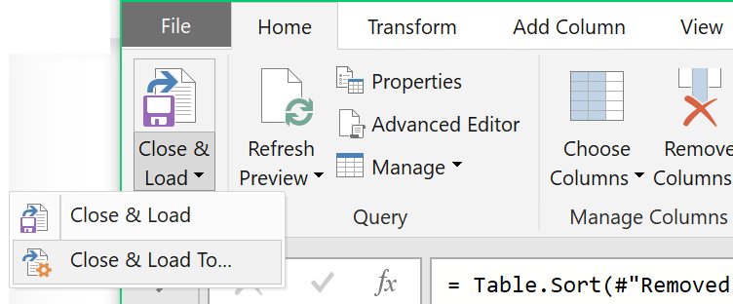



We don’t want to load this data to a spreadsheet (because it has a 1 million row limitation), but right to the data model. So, select Only Create Connection and Add this data to the Data Model. After selecting those two options, click OK.

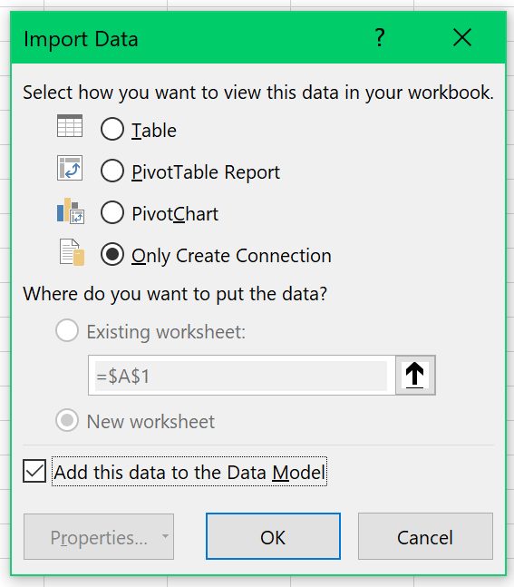



Observe the status of the Queries and Connections in the right pane and watch that all 86,837 records are loaded.

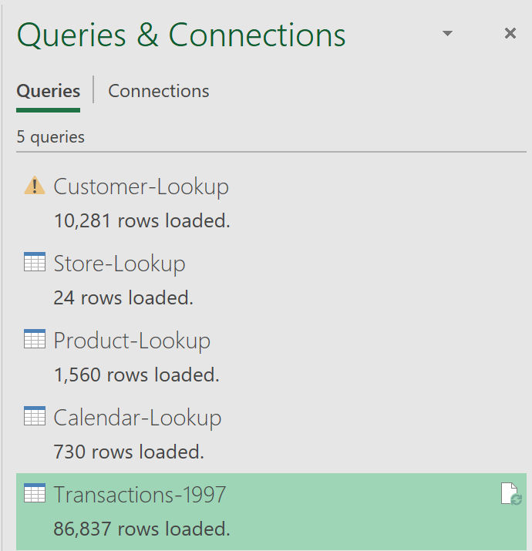



The Transactions-1997 is now accessible in the Data Model. Go to the Power Pivot window by clicking on its icon.



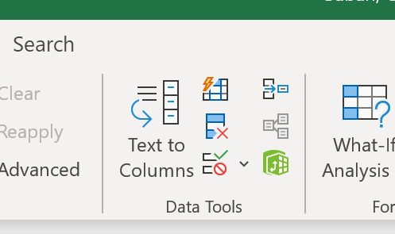



Note the tabs at the bottom of the window. 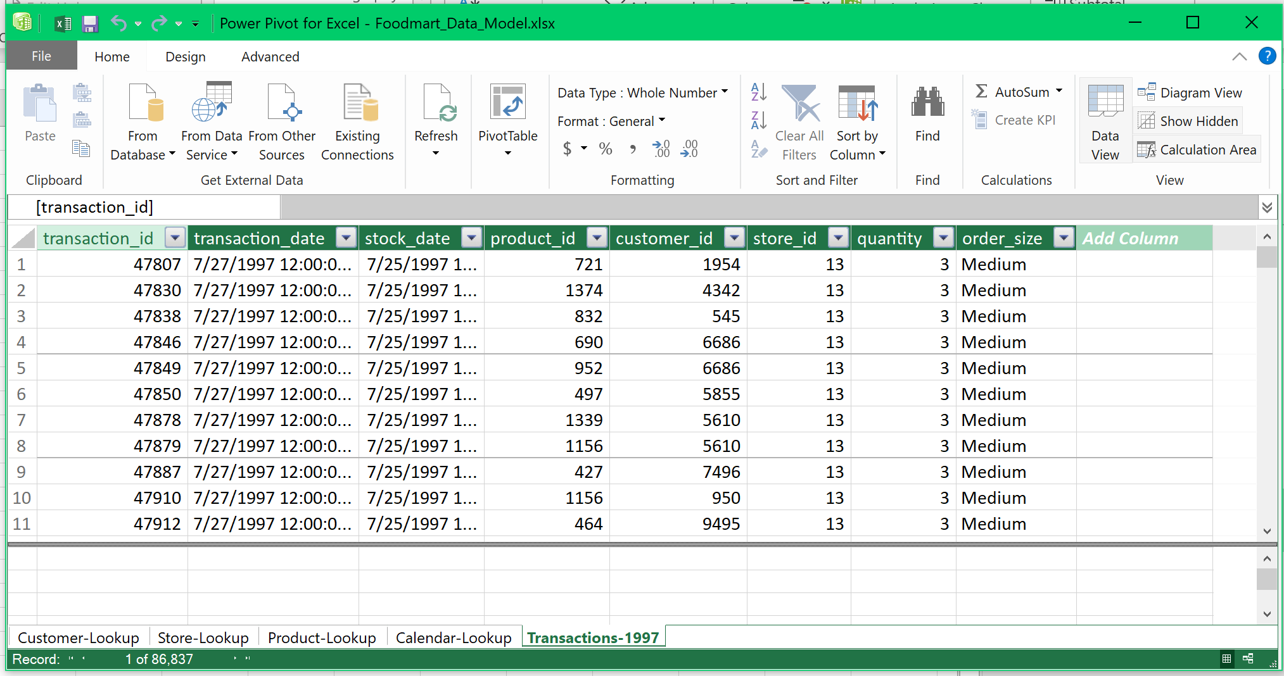



Close the Data Model window to go back to Excel, and save your workbook.

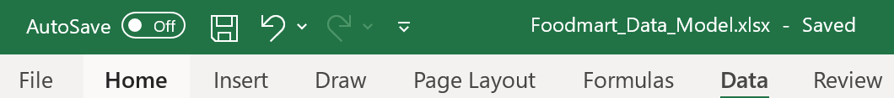



What to submit for Quest #2?

After you save your work:

1. Resize the Excel spreadsheet and take a snapshot using Window's Snipping Tool.
2. Make sure the system's date, your name, and the number of rows loaded are included in the image.
3. Submit to Canvas in PNG format.

